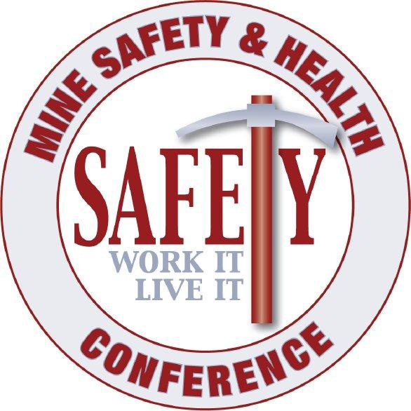
19th Annual Mine Safety and Health Conference October 23rd-25th, 2023
Grand Sierra Resort and Casino, Reno, Nevada

Sponsorship Form

Name: Title: Organization Name: Address: City, State, Zip: Day Phone: E-mail Address:

Foundation Sponsorships
□ Platinum Sponsor ($2,500+) □ Gold Sponsor ($1,500-$2,499)
□ Silver Sponsor ($750-$1,499) □ Copper Sponsor ($500-$749)
□ Claim Stake Sponsor ($250-$499)
“AT THE SHOW”
□ Keynote Speaker Sponsor ($7,500) □ Vendor Reception Sponsor ($7,000)
□ Lunch Sponsor ($3,500) □ Break Sponsor ($1,500)
□ Lanyard Sponsor ($2,000) □ Registration Bag Sponsor ($1,500)

Total Sponsorship Amount $

Special Instructions for Sponsorship (Please include Company logo)

To Pay by Check: (Preferred)
Make checks payable to the “Mine Safety Conference.”

To Pay by Credit Card:
Card Number: Exp / Card Type: (Visa, MasterCard, etc.) Name on Card:
Billing Address: Billing City, State, Zip:

Please contact one of the following with questions:
Joe Riney, Joseph@Nevadamining.com 775-829-2121
Robert Roberts, robert.roberts@simplot.com

E-mail completed form to Joseph@Nevadamining.org, or mail completed form with payment to Nevada Mining Association, Attn: Mine Safety & Health Conference, 3185 Lakeside Drive, Reno, NV 89509

